SAMPLE QUESTION PAPER-1
(TERM I) 2021-22
CLASS XII
BIOLOGY
Time: 90 Minutes General Instructions:
- The Question Paper contains three sections.
- Section A has 24 questions. Attempt any 20 questions.
- Section B has 24 questions. Attempt any 20 questions.
- Section C has 12 questions. Attempt any 10 questions.
- All questions carry equal marks.
- There is no negative marking.

SECTION - A
Section – A consists of 24 questions. Attempt any 20 questions from this section. The first attempted 20 questions would be evaluated.
1 | What structure gets implanted on the wall on the uterus during embryonic development?  - 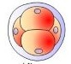  - 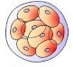  - 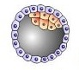  - 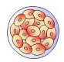
2 | Select the correct statements-  (a) Tapetum nourishes developing pollen grains.  (b) Hilum represents junction between ovule and funicle.  (c) In aquatic plants, Water Hyacinth and Water Lily, pollination is by water.  (d) Primary endosperm nucleus is triploid.  - Only A, B and C are correct  - Only A, B and D are correct  - Only A, C and D are correct  - Only B, C and D are correct
3 | In monosporic type of embryo sac development  - Megaspore mother cell directly acts as a single functional megaspore  - Diploid megaspore mother cell divides to form linear tetrad of four diploid megaspores of which one remains functional  - One megaspore situated in chalaza end remains functional while others degenerate  - One megaspore situated in micropyle end remains functional while others degenerate
4 | Which of the following statements is not true for cross pollination?  - brings about genetic recombination and production of new varieties  - results into inbreeding depression  - may result into production of disease resistant plants  - it can occur in unisexual as well as bisexual flowers.
5 | Persistent nucellus is called as _______ and is found in _______.  - perisperm, black pepper  - perisperm, groundnut  - endosperm, black pepper  - endosperm groundnut
6 | Identify descriptions with the terms and tick the correct option  - a-2, b-1,c-3 2) a-1 ,b-2,c-3 3)a-3 ,b-2,c-1 4) a-3 ,b-1,c-2
  - Spermatogenesis | 1)Transformation of spermatid into spermatozoa
  - Spermiogenesis | 2)Sperm releases from seminiferous tubules
  - Spermiation | 3)Male germ cell produces sperm
7 | Locate the incorrect statement explained for mammary glands.  - mammary lobes contain clusters of cells called alveoli  - alveoli open into mammary tubules  - mammary tubules join to form lactiferous duct  - mammary ducts join to form mammary ampulla
8 | Corelate the events with the phases of menstrual cycle and tick the correct option-  - a – i , b – iv , c – iii , d – ii  - a – iii , b – ii , c – i , d – iv  - a – iv , b – ii , c – iii , d – i  - a – ii , b – iv , c – iii , d – i
  - Menstrual | i)LH and FSH at peak level, estrogen level also high
  - Follicular | ii)Increase in the level of pituitary and Ovarian Hormone, Endometrium of Uterus regenerates.
  - Ovulatory | iii)Breakdown of endometrial lining of uterus
  - Luteal | iv)Graafian follicle transforms as a corpus luteum.
9 | Leydig cells are:  - Present in seminiferous tubules and secretes androgens  - Present in seminiferous tubules and help in maturation of  - Present in interstitial space and secrete androgens  - Present in interstitial space and help in maturation of sperms
10 | Match the following, representing parts of the sperms and it’s functions –  - A – 2 , B – 4 , C – 1 , D – 3  - A – 4 , B – 3 , C – 1 , D – 2  - A – 4 , B – 1 , C – 2 , D – 3  - A – 2 , B – 1 , C – 3 , D – 4
  Column I | Column II
  - Head | - Sperm Lysins
  - Middle Piece | - Sperm Motility
  - Acrosome | - Powerhouse
  - Tail | - Genetic Material
11 | Identify the correct sequence for different stages of embryo development in dicot  - Zygote –Globular Embryo – Heart Shaped Embryo - Mature embryo  - Zygote – Mature embryo – Heart Shaped Embryo -– Globular Embryo  - Mature embryo - Zygote –– Globular Embryo – Heart Shaped Embryo  - Heart Shaped Embryo -Zygote – Mature embryo – Globular Embryo
12 | If a genetic disease is transferred from a phenotypically normal but carrier female to only some of the male progeny, the disease is  - autosomal dominant  - autosomal recessive  - sex-linked dominant  - sex-linked recessive.
13 | In sickle cell anemia, 1 is substituted by 2 at 3 position of β-globulin chain. Identify the correct one-
  1 | 2 | 3
  - Glutamic acid | Phenylalanine | 3rd
  - Glutamic acid | Valine | 3rd
  - Valine | Glutamic acid | 6th
  - Glutamic acid | Valine | 6th
14 | Which of the following will not result in variations among siblings ?  - Independent assortment of genes  - Crossing over  - Linkage  - Mutation
15 | Identify the incorrect match :
  (a) Incomplete dominance—Dog flower  (c) Male heterogamy—Human | (b) Co-dominance—Blood groups  (d) Female heterogamy—Grasshopper
16 | Heterozygous tall pea plant is crossed with a dwarf pea plant. This is:
  (a) Dihybrid cross  (c) Co-dominance | (b) Test cross  (d) Multiple allelism
17 | In a family, father has a blood group 'A' and mother has a blood group 'B', Children show 50 % probability for a blood group "AB" indicate that -  - Father is heterozygous  - Mother is heterozygous  - Either of parent is heterozygous  - Mother is homozygous
18 | Steps of DNA fingerprinting are given following. Arrange them in a correct sequence :  - Action of restriction endonucleases.  - Hybridization of DNA fragments by using labeled VNTRs.  - Isolation of DNA.  - Identification of hybridized DNA fragments by autoradiography  - Separation of DNA by electrophoresis.  - 5,1,2, 4, 3  - 3,1,5, 2, 4  - 3,1,4,2, 5  - 5,1,3, 4, 2
19 | In Griffith s transforming principle, when heat killed S-strain is injected into mice, then:  - Transformation of S-strain into R-strain will occur  - Transformation of R-strain into S-strain will occur  - Mice died  - Mice was alive
20 | Fill 1,2,3 by suitable option-  In prokaryotes like E. coli, 1-------- charged DNA is present in large loops held by 2 ------charged 3------ to form nucleoid.  - 1-Positively, 2-Negatively, 3-Fatty acids  - 1-Negatively, 2-Positively, 3-Proteins  - 1-Negatively, 2-Positively, 3-Fatty acids  - 1-Positively, 2-Negatively, 3-Proteins
21 | A free phosphate moiety can be observed at one end of a polynucleotide chain attached to:  - 3'—end of pentose sugar  - 5— end of pentose sugar  - 3'—end of nitrogenous base  - 5'—end of nitrogenous base.
22 | Escherichia coli fully labelled with 15N is allowed to grow in 14N medium. The two strands of DNA molecule of the first-generation bacteria have  - different density and do not resemble parent DNA  - different density but resemble parent DNA  - same density and resemble parent DNA  - same density but do not resemble parent
23 | What would happen if in a gene encoding a polypeptide of 50 amino acids, 25th codon (UAU) is mutated to UAA ?  - A polypeptide of 24 amino acids will be formed.  - Two polypeptides of 24 and 25 amino acids will be formed.  - A polypeptide of 49 amino acids will be formed.  - A polypeptide of 25 amino acids will be formed.
24 | Match the column in COLUMN I with those in COLUMN II  - A – 2 , B – 3 , C – 1  - A – 1 B – 2 , C – 3  - A – 3 , B – 2 , C – 1  - A – 3 , B – 1 , C – 2
  COLUMN I | COLUMN II
  - RNA polymerase I | - A set of three bases on tRNA that is complementary to the bases
  - Anticodon | - A unit of DNA that codes for a polypeptide
  - Cistron | - Transcribes RNASs

SECTION - B
Section - B consists of 24 questions (Sl. No.25 to 48). Attempt any 20 questions from this section.
The first attempted 20 questions would be evaluated.
Question No. 25 to 28 consist of two statements – Assertion (A) and Reason (R). Answer these questions selecting the appropriate option given below:
- Both A and R are true and R is the correct explanation of A
- Both A and R are true and R is not the correct explanation of A
- A is true but R is false
- A is False but R is true
25 | Assertion: ICSI is an assisted reproductive technique.  Reason: In ICSI sperm is directly injected into the ovum to form an embryo in vitro
26 | Assertion: In Mirabilis, selfing of F1 pink flower plants produces same phenotypic & genotypic ratio.  Reason : Flower colour gene shows incomplete dominance.
27 | Assertion: Breast feeding during initial period of infant growth is recommended.  Reason: Colostrum contains several antibodies, essential to render immunity in newborns.
28 | Assertion: The embryo with 8 to 16 blastomeres is called a morula.  Reason: The morula continues to divide and transforms into trophoblast.
29 | Identify the incorrect match:
  Contraceptive Device | Type | Mode of action
  (a) Multiload 375 | IUD | Phagocytosis of sperms and inhibitory effect of copper ions
  (b) Condoms | Barrier method | Prevent the meeting of sperm of ovum
  (c) Saheli | Oral steroidal contraceptive pill | Inhibit ovulation and implantation
  (d) LNG-20 | IUD | Phagocytosis of sperms and release of hormone
30 | When a female should take oestrogen-progesterone combined pills, during menstrual cycle?  - All 28 days  - For 21 days, starting from the 1st day of menstruation  - For 21 days, starting from first five days of menstrual cycle  - For 7 days, during menstruation
31 | An embryo sac is shown in the given diagram. Select the option with correct identification  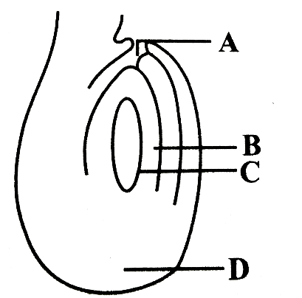  - A Chalaza B Female gametophyte C Embryo sac D Micropyle  - A Chalaza B Nucellus C Embryo sac D MicropyleC  - A Micropyle B Egg C Embryo sac D Chalaza  - A Micropyle B Nucellus C Embryo sac D Chalaza
32 | The endocrine structure and the corresponding hormones are listed in the table below. Match the columns and select the correct option.  - (a) - (iv), (b) - (iii), (c) - (i), (d) - (ii)  - (a) - (i), (b) - (iii), (c) – (iv), (d) - (ii)  - (a) - (iv), (b) - (ii), (c) - (iii), (d) - (i)  - (a) - (ii), (b) - (iv), (c) - (i), (d) – (iii)
  Column I | Column II
  (a) Hypothalamus | (i) Estrogen
  (b) Anterior Pituitary | (ii) FSH and LH
  (c) Testis | (iii) Androgens
  (d) Ovary | (iv) Gonadotropin releasing hormone
33 | During IVF-ET (In vitro fertilization embryo transfer), after fertilization if embryo is having 8 or less number of blastomeres, than it is transferred to A while if the number is more than 8, it is transferred to B .  - A = Fallopian tube, B = Fallopian tube  - A = Fallopian tube, B = Uterus  - A = Uterus, B = Fallopian tube  - A = Uterus , B = Uterus
34 | 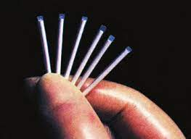  Select the option with correct identification of the given contraceptive measure and the hormone essentially present in it.
  (a) | CopperT | Progesterone
  (b) | CopperT | Oestrogen
  (c) | Implant | Progesterone
  (d) | Implant | Oestrogen
35 | 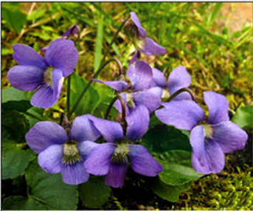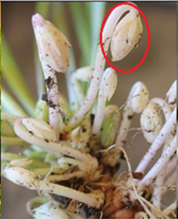  A B  - A is chasmogamous flower and it promotes autogamy  - A is cleistogamous flower and it promotes autogamy  - B is chasmogamous flower and it promotes geitonogamy  - B is cleistogamous flower and it promotes autogamy
36 | The heavy DNA molecule could be distinguished from the normal DNA by  - Cesium chloride density gradient centrifugation  - Centrifugation  - Filtration  - Autoradiography
37 | Thalassemia and sickle cell anemia are caused due to a problem in globin molecule synthesis. Select the correct statement.  - Both are due to the qualitative defect in the globin chain synthesis.  - Thalassemia is due to less synthesis of globin molecules  - Sickle cell anemia is due to a quantitative problem of globin molecules  - Both are due to a quantitative defect in globin chain synthesis.
38 | What is the probability of production of dwarf offspring’s in a cross between two heterozygous tall pea plants ?  - Zero  - 50 %  - 25 %  - 100 %
39 | The genotypes of a husband and wife are I^{A}I^{B} and I^{A}i. Among the blood types of their children, how many different genotypes and phenotypes are possible?  a) 3 genotypes; 4 phenotypes  b) 4 genotypes; 3 phenotypes  c) 4 genotypes; 4 phenotypes  d) 3 genotypes; 3 phenotypes
40 | A woman with normal vision, but whose father was colorblind, marries a colorblind man. Suppose that the fourth child of this couple was a boy. This boy  - May be colorblind or may be of normal vision  - Must be colorblind  - Must have normal color vision  - Will be partially colorblind since he is heterozygous for the colorblind mutant allele.
41 | A nucleosome is given in the diagram. Select the option with correct identification:  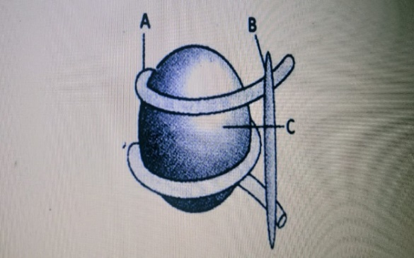
   | A | B | C
  (a) | RNA | Non-histone | DNA !
  (b) | DNA | Histone ostamer | Hi histone
  (c) | RNA | Hi histone | Non-histone protein
  (d) | DNA | Hi histone | Histone octamer
42 | Which one of the following is wrongly matched?  - Transcription writing information from DNA to tRNA.  - Translation Using information in mRNA to make protein.  - Repressor protein binds to operator to stop enzyme synthesis.  - Operon -Structural genes, operator and promoter.
43 | Select the two correct statements out of the four (i –iv) statements given below about lac  operon.  - Glucose or galactose may bind with the repressor and inactivate it.  - In the absence of lactose, the repressor binds with the operator region.  - The gene z codes for permease.  - This was elucidated by Francois Jacob and Jacques Monod.  The correct statements are
  (a) (ii) and (iii)  (c) (ii) and (iv) | (b) (i) and (iii)  (d) (i) and (ii).
44 | A t-RNA is bound to m-RNA. Identify A, B and C.  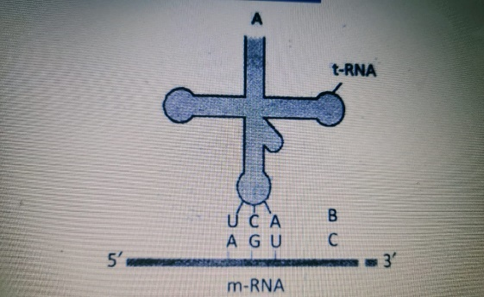
   | A | B | C
  (a) | Amino-acyl binding site | Anti-codon | Codon
  (b) | Ribosomal binding site | Anti-codon | Codon
  (c) | Ribosomai binding site | Codon | Anti-codon
  (d) | Amino-acyl binding site | Codon | Anti-codon
45 | Match the items in Column—I with those in Column—II:
  A | r-RNA | (i) | Termination factor
  B. | m-RNA | (ii) | Catalytic role in translation
  C. | ρ | (iii) | Reads the genetic code
  D. | t-RNA | (iv) | Provides the template
  E. | σ | (v) | Initiation factor
  (a) A-(ii), B-(iv), C-(i), D-(iii), E-(v)  (c) A-(iii), B-(ii), C-(v), D-(iv), E-(i) | (b) A-(iv), B-(ii), C-(i), D-(iii), E-(v)  (d) A-(iv), B-(iii), C-(v), D-(ii), E-(i)
46 | Which of the following is a correct representation of transcriptional unit?  - 5 ‘— Promoter — Structural gene — Terminator —3'  - 5 ‘— Structural gene — Promoter — Terminator —3'  - 5’ — Structural gene — Terminator — Promoter —3'  - 5'— Promoter — Terminator — Structural gene —3’
47 | Match the columns-
   | Column A |  | Column B
  A. | Splicing | 1. | Removal of introns
  B. | Initiation | 2. | Addition of nucleotides at 5'-end
  C. | Tailing | 3. | Addition of adenylate residues at 3'-end
  D. | Capping | 4. | Addition of methionine
  (a) A-4, B-1, C-3, D-2  (c) A-1, B-4, C-2, D-3 | (b) A-1, B-4, C-3, D-2  (d) A-4, B-1, C-2, D-3
48 | Read the following steps involved in translation and arrange them in correct sequence.  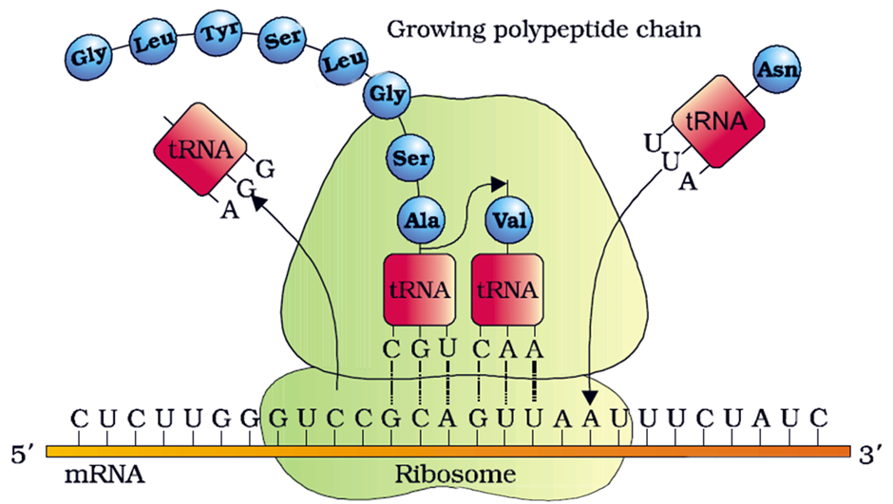
  (A) Chain elongation  (C) Charging of t-RNA  (E) Activation of amino acids  (a) B→E→A→C→D→F  (c) B→E→F→C→A→D | (B) Initiation  (D) Termination  (F) Formation of peptide bond  (b) E→C→B→F→A→D  (d) E→B→C→F→A→D

SECTION – C
Section-C consists of one case followed by 6 questions linked to this case (Q.No.49 to 54). Besides this, 6 more questions are given. Attempt any 10 questions in this section.
The first attempted 10 questions would be evaluated.
CASE- Read the following and answer any four questions from 49 to 54 given below :
Study the given table and answer the following question based on it.
 | Hormone | Source | Function
(A) | Oxytocin | W | Ejection of Milk
(B) | X | Anterior lobe of Pitutary Gland | Stimulates secretion of ABP from Sertoli cells
(C) | Y | Placenta | Maintain corpus luteum to secrete progesterone
(D) | Relaxin | Ovary | Z

49 | Identify the hormones X and Y respectively  - Testosterone, FSH  - LH, Hpl  - FSH, HCG  - ICSH, HCG
50 | W in the given table is  - Hypothalamus  - ovary  - Placenta  - Ovary
51 | Which of the following is correct for Z?  - Dilation of uterine cervix during labour pains  - Stimulates the growth of the mammary glands during pregnancy  - Supports the fetal growth and prevents desiccation  - Forms protective plug in cervix of uterus during pregnancy
52 | Which set of hormones is secreted only during pregnancy?  - Human chorionic gonadotropin, relaxin and human placental lactogen  - Human placental lactogen, estrogen and chorionic thyrotropin  - Human chorionic gonadotropin, human placental lactogen and progesterone  - Chorionic thyrotropin, chorionic gonadotropin and estrogen
53 | Urine test during pregnancy determines the presence of  (a) human chorionic gonadotropin hormone  (b) estrogen  (c) progesterone  (d) luteinising hormone.
54 | Which part of ovary in mammals acts as an endocrine gland after ovulation ?  (a) Stroma  (b) Germinal epithelium  (c) Vitelline membrane  (d) Graafian follicle
55 | What will be the condition of the progeny if the father is normal, while the mother has one gene for haemophilia and one gene for colour blindness on one of the X chromosomes?  - Only daughters are haemophilic and colour blind  - Both sons and daughters will be haemophilic and colour blind  - 50 per cent haemophilic and colour blind sons and 50% normal sons  50 per cent haemophilic colour blind daughters and 50% colour blind daughters
56 | A, B and C are three enzymes involved in lac operon. Identify them :  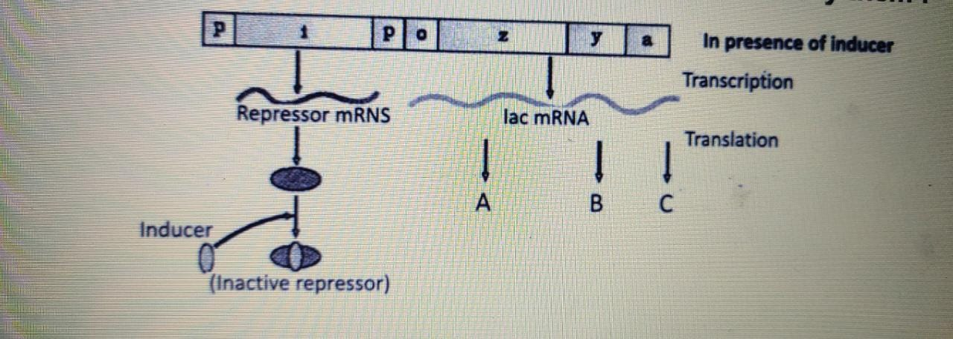
   | A | B | C
  (a) | Permease | β-galactosidase | Transacetylase
  (b) | β-galactosidase | Permease | Transacetylase
  (c) | β-galactosidase | Transacetylase | Permease
  (d) | Permease | Transacetylase | β-galactosidase
57 | Observe the given crosses (A and B) done in Drosophila.  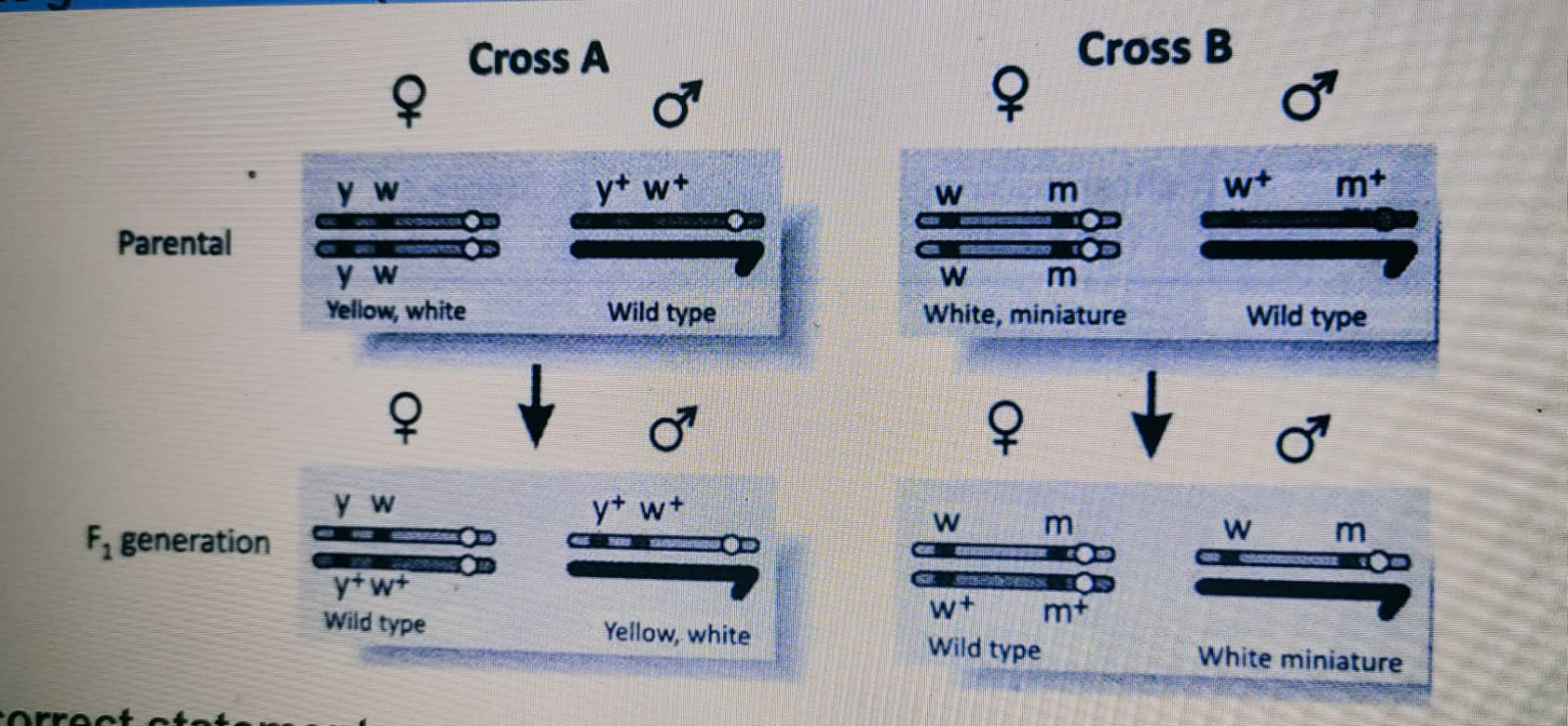  Select the incorrect statement.  - y and w are more linked than w and m  - Recombinants will be more in number in cross A than cross B  - In cross A, parental type will be more than thecombinants  - In cross B, parental type will be more than recombinants
58 | Study the diagram given below and choose the correct information that can be deduced:  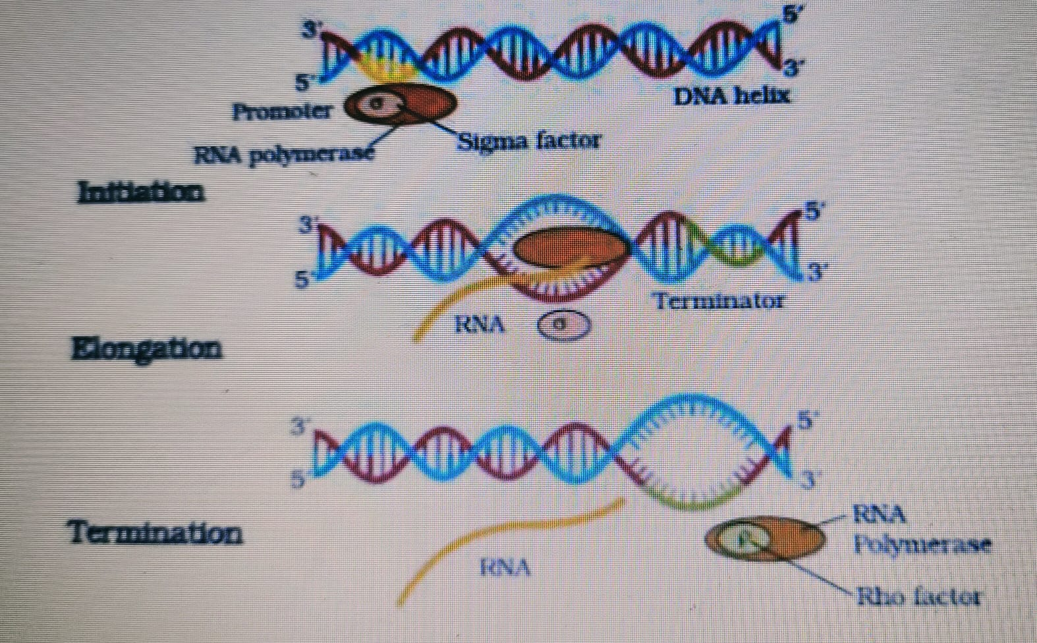  - The core RNA polymerase is capable of catalyzing elongation only  - Sigma factor and Rho factor are needed for termination of transcription  - DNA Helicase opens the strand of the DNA  - Both strands of DNA are transcribed by the same RNA polymerase
59 | Which of the following would not be a feature seen in a patient with the following karyotype?  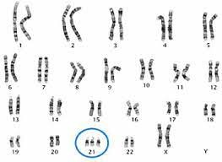  - Many loops on finger tips  - Congenital heart disease  - Big and wrinkled tongue  - Mucus clogging of airways  Chromosome number becomes 47 in :  - Turner’s syndrome  - Sickle cell anemia  - Down’s syndrome and Klinefelter’s syndrome  - Klinefelter’s synctrome
60 | Given below is the initial amino acids of the beta chain of a hemoglobin molecule.  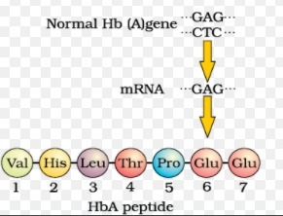  What will be true about this hemoglobin molecule?  - The RBCs carrying this molecule will undergo sickling at high oxygen tension  - The RBCs carrying this molecule will undergo sickling at low oxygen tension  - There will be a quantitative decrease in the synthesis of this molecule  - This is normal beta chain of the hemoglobin molecule

