KENDRIYA VIDYALAYA SANGATHAN

Class XII (2019-20)
Biology (044)

Time allowed: 3 hrs. Maximum Marks: 70

General Instructions:
- There are a total of 27 questions and five sections in the question paper. All questions are compulsory.
- Section A contains question numbers 1 to 5, multiple choice questions of one mark each. Section B contains question numbers 6 to 12, short answer type I questions of two marks each. Section C contains question numbers 13 to 21, short answer type II questions of three marks each.
Section D contains question number 22 to 24, case-based short answer type questions of three marks each.
Section E contains question numbers 25 to 27, long answer type questions of five marks each.
- There is no overall choice in the question paper. However, internal choices are provided in two questions of one mark, one question of two marks, two questions of three marks and all three questions of five marks. An examinee is to attempt any one of the questions out of the two given in the question paper with the same question number.

SECTION A
Q 1) How many functional sperms and how many ova will be formed by a primary spermatocyte and a primay oocytes respectively-
a) one,one
b) one,four
c) four , one
d) four,four
OR
A procedure that finds use in testing for genetic disorders, but is also misused for female foeticide is:
A) Lactational amenorrhea
B) Amniocentesis
c) Artificial insemination
d) Parturition

Q 2) Use of antihistamine and steroids gives a quick relief from-
- Allergy
- Nausea
- Cough
- Fever
OR
Rheumatoid arthritis is caused when . . .
- Lymphocytes become more active
- Body attacks self cells
- More antibodies are produced in the body
- The ability to differentiate pathogens or foreign molecules from self-cells is lost
Choose the correct answer from the options given below:
a) i and ii
b) iii and iv
c) i and iii
d) ii and iv

Q 3) The DNA polymerase enzyme used in PCR is obtained from
(a) Thermus aquaticus
(b) Escherichia coli
(c) Agrobacterium tumefaciens
(d) Salmonella typhimurium.
Q 4) Significance of ‘heat shock’ method in bacterial transformation is to facilitate [NCERT Exemplar]
(a) binding of DNA to the cell wall
(b) uptake of DNA through membrane transport proteins
(c) uptake of DNA through transient pores in the bacterial cell wall
(d) expression of antibiotic resistance gene
Q 5) It natality is balanced by mortality in a population at a given time, there will be a/an
(a) decrease in the population size
(b) increase in the population size
(c) zero population growth
(d) population explosion
SECTION –B
Q 6) How does an encysted Amoeba reproduce on return of favourable conditions? 2

OR
What are gemmules and conidia? Name one organism each in which these are formed?
Q 7) Name any two copper releasing IUD’s. State how they act as a contraceptive. 2
Q 8) A man with blood group O married a woman with blood group AB. Show the possible blood group of the progeny with the help of a cross. List the alleles involved in this inheritance.
Q 9) Why tendrils of Cucurbita and thorns of Bougainvillea are called homologous organs? What does this homology indicate? 2
Q 10) Name the technology and write the procedure that can help a scientist to recover virus free sugarcane plants from diseased canes for his crop breeding experiments.
Q11) Explain the events that occur in the host cell on introduction of nematode-resistant gene into the tobacco plant by using Agrobacterium vectors.
Q12) Construct a pyramid of biomass starting with phytoplankton. Label its three trophic levels. Is the pyramid upright or inverted? Justify your answer.2

SECTION –C
Q 13.]Draw diagram of mature embryo sac and label following parts : a)Chalazal end and Micropylar end b) Antipodal cells c) Synergids and Egg d) Polar nuclei and central Cell (3)

Q 14.] (a) Describe the endosperm development in coconut. [ 3]
- Why is tender coconut considered as healthy source of nutrition.
- How are pea seeds differ from castor seeds with respect to endosperm.

Q15)Study the table given below and identify (i), (ii), (iii) and (iv) [ 3]

Amino acid | Phe | Val
DNA Code in  Gene | AAA | CAC
Codon in mRNA | (i) | (ii)
Anticodon in tRNA | (iii) | (iv)

- A polypeptide consists of 14 different amino acids.
A)How many base pairs must be there in the processed mRNA that codes for this polypeptide?
B)How many different types of tRNA are needed for the synthesis of this polypeptide
Q 16) How has RNA interference technique helped to prevent the infestation of roots in tobacco plants by a nematode Meloidegyne incognita?

OR
How human insulin was prepared using r DNA technique by Eli Lilly company? How the insulin thus produced was different from that produced by human body?
Q17) a) Why Biofertilizers are preferred over chemical fertilizers these days?
- How do Mycorrhiza and Anabaena act as biofertilisers?
Or
- State two limitations of traditional breeding technique that led to promotion of Micropropagation.
- Define somatic hybridization.
- Mention the economic value of Spirulina.
Q18) State any two criteria for determining biodiversity hotspots. Name any two hotspots designated in India.

OR
Differentiate between in-situ and ex-situ approaches for conserving biodiversity. Give an example for each.
Q 19) “Specific Bt Toxin gene is incorporated into cotton plant so as to control infestation of Bollworm”. Mention the organism from which the gene was isolated and explain its mode of action 3
Q 20) How will you measure population density in following cases?
  - Fish in a lake
  - Tiger census in a national park
  - Single huge banyan tree with large canopy
Q 21)Draw the life cycle of malarial parasite showing both its sexual and asexual stages. (3)
Section -D

Q22) The diagram below is a schematic representation of spermatogenesis. Identify the steps of spermatogenesis and fill in the gaps A,B,C,D and E in the following:

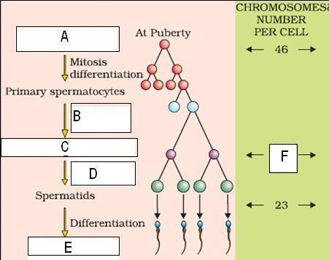

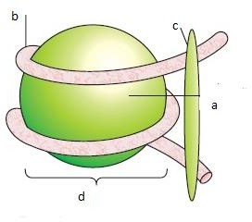
Q 23)What is this diagram representing? (b)Name the part a,b,c C) How can you differentiate between euchromatin and heterochromatin?
Q 24) 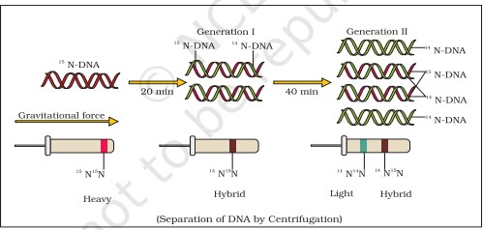

Based on the Diagram answer the following questions:
- Write the name of the chemical substance used as a source of nitrogen in the experiment.
- Which salt was used for centrifugation purpose?
- Write the conclusion the scientists arrived at after completing the experiment?

Section -E
Q 25) a) What is altitude sickness? How it is caused? How does human body try to overcome altitude Sickness?
b) How does our body maintain constant temperature during winter, when the outside temperature is much lower than our body’s temperature? [5]

OR
  - Explain co-evolution with reference to parasites and their hosts? Mention any four special features evolved in parasites for their parasitic mode of life?
Q 26)fill in the blanks-
S.no | Name of the organism | Commercial product | application
1 | Penicillium notatum | penicillium | (a)
2 | (b) | Lactic acid | Making curd
3 | streptococcus | (c) | Clot buster
4 | Trichoderma polysporum | (d) | Immunosuppressive agent
5 | Saccaromyces cerevisiae | ethanol | fermentation
6 | (e) | Swiss cheese | Food product

Or

Q26) Write down the steps involved in treatment of polluted water to pure water.What do you mean by primary sludge and activated sludge explain.
Q 27)What does the lac operon consist of?How is the operator switch turned on and off in the expression of genes in this operon.explain with the help of diagrams.
Or
Q 27) Explain the process of transcription with the help of diagram.Also write a short note on post transcription modifications

---------------------------------------------------

