HALF YEARLY EXAMINATION
MARKING SCHEME - CLASS XI
BIOLOGY

Q.NO. | KEY POINTS | MARKS
1 | Mycoplasma | 1
2 | Whorled/tendrils and thorns | 1,1/2+1/2
3 | RER-Protein, SER- -Lipids/ This is formed by the extensions of plasma membrane in to the cell. These extensions are in the form of vesicles, tubules and lamellae. They help in cell wall formation,DNA replication and distribution to daughter cell. | 1/2+1/2,1
4 | - Metaphase ii) anaphase | 1,1/2+1/2
5 | Temperature and pH or any other | 1,1/2+1/2
6 | Closely associated with sieve tube elements- phloem. It helps in maintaining the pressure gradient in the sieve tubes. | 2
7 | Nephridia, radula | 1+1
8 | Justification,pneumatic bones, presence of feathers | 2
9 | Mitochondria and chloroplasts .mitochondria-They are the sites for cellular respiration. Chloroplast-The main function of plastids is to provide different colours to different parts of different organs.  Meta,submeta,acro,telocentric | 1/2x4=2/  1/2x4=2
10 | Humans use secondary metabolites as medicines, flavorings, pigments, and recreational drugs. Secondary metabolites aid a host in important functions such as protection, competition, and species interactions, but are not necessary for survival.(any two) | 2
11 | Alternation between Gamete producing haploid gametophyte and spore producing diploid sporophyte, explanation of any one(haplontic, diplontic, haplodiplontic) | 1+1
12 | labrum, mandibles, maxillae and labium | ½ mark each
13 | 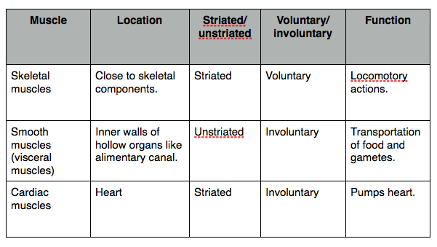 | 1+1+1 = 3
14 | Structure with diagram/explaination | 3
15 | Polyp – sessile, it produces Medusa asexually e.g. Hydra , Adamsia and Medusa –free floating, produces polyp sexually , e.g. Obelia | 1+1+1=3
16 | Phaeophyceae:  •Major pigments- chlorophyll a,c,fucoxanthin  •Stored food- Mannitol, laminarin  •Cell wall- Cellulose and algin  Rhodophyceae:  •Major pigments- chlorophyll a,d, phycoerythrin  •Stored food- Floridean, starch  •Cell wall- Cellulose, pectin and polysulphate esters. | 3
17 |  | 1+1+1=3
  (a) hypogynous, if sepals, petals and stamens are attached to the receptacle below the ovary. The ovary in this case is said to be superior ex- mustard,tomato.
  (b) perigynous, if sepals, petals and stamens are fused at the base of the ovary. The ovary in this case is still superior. (cherry, rose) | through a perigynous flower.
  (c) epigynous, if sepals, petals and stamens arise from the top of the ovary, The ovary of an epigynous flower is inferior.guava and cucumber | flower.
18 | Specialised epidermal cells in the vicinity of the guard cells., conjoint open,common in stem and leaves | 1+1+1=3
19 | More carboxylic group , more amino group, equal amino and carboxylic  Valine, Glycine-Neutral amino acid  Lysine, arginine-Basic amino acid.  Aspartic and glutamic acid – acidic  Classification of enzymes-oxidoreductase,transferases,hydrolases,isomerases,ligases,.lyases | 1½+1½=3/  1/2x6=3
20 | - Meristematic-These tissues have the capacity to divide.ex-cambium and root apex(explaination)  - Permanent-These tissues have lost the capacity of division.ex-xylem phloem  (explaination)  /Page no. 95 ncert | 1½+1½=3
21 | Fig.8.9 (b) page 137 NCERT Book –Diagram with four labelling  - Covered with plasma membrane.  - The core- Axonneme  - Axonome-9 pairs of doublets of radially arranged peripheral microtubules.(9+2)  - Nine radial spokes.  - Centriole like structure- basal bodies | 2+1
22 | Enzymes bring down the energy barrier between a substrate and the product making the reaction easy and fast. Lower the activation energy higher will be therate of reaction and higher the activation energy lower will be the rate of reaction. ... stabilizing the transition state | 3
23 | 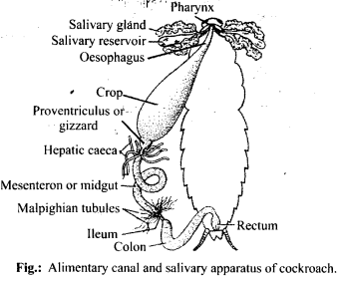  - Transfer of sperm b)supplies nerves to antennae and compound eye c)helps in grinding food particles | 3  1+1+1
24 | energy required to start a reaction. Enzymes are proteins that bind to a molecule, or substrate, to modify it and lower the energy required to make it react. Adding a catalyst has this effect on activation energy. A catalyst provides an alternative route for the reaction with a lower activation energy. This is illustrated on the following energy profile:  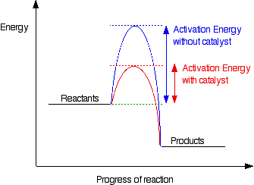 | 1+1+  1
25 | - Palisade tissue  - i) Xylem tracheids, (ii) Xylem vessels, (ii) Xylem parenchyma, (ii) Xylem fibres., tracheids sclerenchyma cells have thick, lignified secondary walls, lack cell contents at maturity, and occur throughout all plant tissues sclereids.  or  1) simple squamous : extremely flat and form delicate lining .  present in inner lining of mouth.  2) stratified squamous : when simple squamous epithelial is arranged in many layers. present in skin.  columnar : pillar like tall cells. present in inner lining of intestine.  ciliated columnar : columnar epithelial cells have hair like projections called cilia. present in respiratory tract.  4) cuboidal : cube shaped cells. present in inner lining of kidney.  5)glandular : a portion of the epithelium tissue fold inwards. present in glands {sweat gland ,oil gland etc.}  An endocrine gland secretes its products, for example hormones, directly into the blood. ... An exocrine glandsecretes its products for example enzymes, into ducts that lead to the target tissue. | 1+1+1+1+1
26 | - Water vascular system Echinodermata-correct e.g  - Malpighian tubule : Arthropoda correct e.g  - Cnidoblasts present: cnideria correct e.g  - Triploblastic Acoelomate animals: Platyhelminthes - correct e.g  - Bioluminescence and comb plates:. Ctenophore- correct e.g  Or  Refer table 4.1 pg55 and pg 56 | 1+1+1+1+1
27 | Ncert page no 163 fig. 10.1  Explanation of interphase  Or  Ncert page no 169 and explaination | 2+3=5  2+3=5

